**Part 4 – Factorising**

1. **Pull out the greatest common factor (the largest thing that divides each term)**

**Example.** Factor



**Example.** Factor



1. **Factor by grouping**

**Example.** Factor



1. **Factor quadratics**



**Example.** Factor

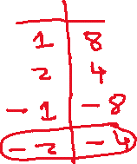

**Example.** Factor

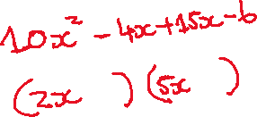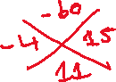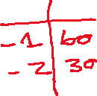

1. **Difference of squares**



**Example.** Factor



**Example.** Factor



1. **Difference or sum of cubes**

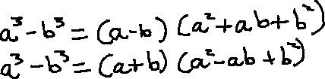

**Example.** Factor

